Your Library Logo here

State of Wisconsin
DEPARTMENT OF NATURAL RESOURCES
101 S. Webster Street
Box 7921
Madison WI 53707-7921
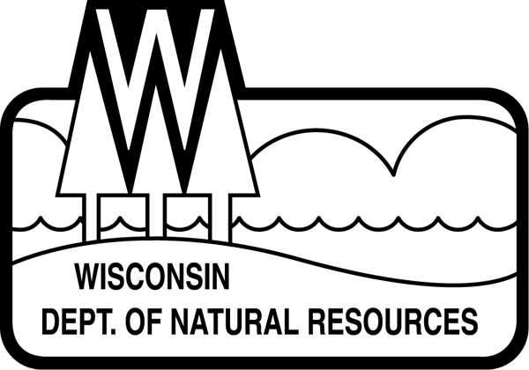
FOR IMMEDIATE RELEASE : Date
Contact: Name, title
Email & phone #

Check Out Wisconsin’s State Parks At Your Library
Pilot Program Plans To Increase Park Access

MADISON, Wis. – The Wisconsin Department of Natural Resources (DNR) and [your library here] today announced a pilot program to make state park and forest vehicle admission day passes available to library card holders at [your library here].

Starting Tuesday, Nov. 1, library card holders at 20 libraries across Wisconsin can check out a pass for free admission for one vehicle at any state park, forest or recreation area where admission is required. The pilot program ends March 1, 2023.

“The DNR is continually looking for innovative opportunities to bring more people to state parks and forests and to ensure everyone in Wisconsin has access to our incredible natural resources,” said Steve Schmelzer, Director of the DNR Bureau of Parks and Recreation. “By partnering with Wisconsin’s library system, we can reach households who may not be as familiar with the wide array of opportunities Wisconsin’s state parks and forests offer.”

The pilot program, Check Out Wisconsin’s State Parks At Your Library, is a collaborative effort between the DNR, Wisconsin Library Association’s Wisconsin Association of Public Libraries and Wisconsin Department of Public Instruction. Nicolet Federated Library System and Southwest Wisconsin Library System underwrote the day passes cost.

[Insert quote from local librarian here. Something along the lines of… “Our library provides resources for everyone of all ages and backgrounds about a broad range of topics, so adding access to our state park system is a natural fit. We are excited to participate as a pilot library, and we hope to see this program flourish in our community. Anyone with questions about the program should stop by the library,” said (library representative name and title here).]

Along with the day pass, the cardholder will receive an informational kit of state park system materials and maps, a Wisconsin Explorer Program book, stickers, accessibility information and more. The program’s goal is to expand access to the Wisconsin state park system to new park visitors. [Your library here] received 50 passes, each with a one-time use.

Based on participant feedback and funding, the DNR plans to continue the program in 2023. Each pass includes a survey link so the DNR can gather information about who used the passes and how they enjoyed their park experience. After using the pass, participants who complete the survey will be eligible to win one of ten 2023 annual state park and forest vehicle admission stickers paid for by the Friends of Wisconsin State Parks.

Learn more about [your library here] and how to get a library card here. (link to your library) For more information about the pilot program, read more here.
# # # #

