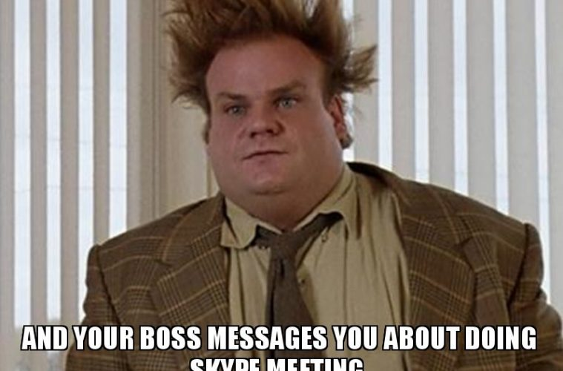

Wisconsin Library Association
Youth Services Section Board Meeting
Friday, April 24th
2pm - 3pm

Present: Emily Zorea, Katherine Schoofs, Susie Menk, Sue Abrahamson, Tessa Schmidt, Florence LaBeau,

Not enough people to meet, no quorum.

Discussed: YSS powerhouse presents webinar ideas Sue suggested webinar included intent and how to find engagement with community

Discussed trying to find who is in charge of membership committee and if we can find out and what their job is Sue will email Sarah C. to see if she knows

Virtual Meeting link: https://global.gotomeeting.com/join/398307397

Approve Agenda
Welcome

Old Business:
Public/School Libraries Group - Katie
YSS Luncheon--Katie
YSS Powerhouse Presents - Katie
Marketing Committee - Anne & Katherine
- YSS email: highlighting key blog posts? Katherine S. chooses?
- YSS Facebook posts: images highlighting specific posts?
New Business:
COVID-19 - How can we continue providing support to library staff serving youth and families? Especially with Summer Reading fast approaching?
YSS Elections - Katie
Regional Meet Ups - Flo & Katherine
Conference Committees
- WAPL update - Katherine
- WLA - Florence & Emily
- Storytime Resource
- Form Letter
- YA SIG
YSS Unit Leadership Roster - Where can we find the current membership committee members?
WLA Board Report Liaison - Sue
DPI - Tessa

Adjourn

